**First derivative Edge Detection**

**Sobel:** 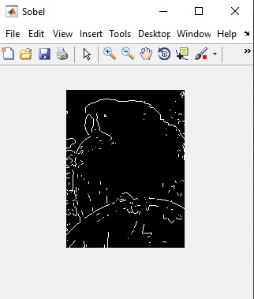

**Prewitt:** 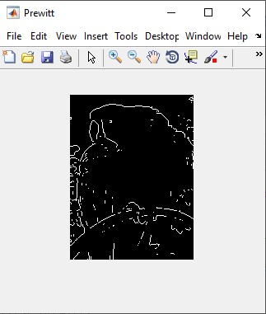

**Roberts:** 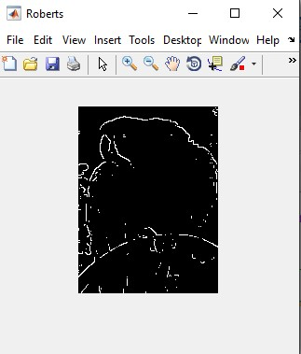

**Second Derivative Edge Detection**

**Log:** 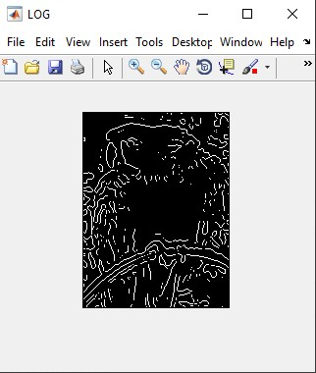

**Zerocross:**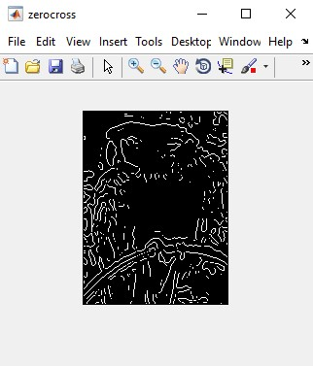

**Canny:** 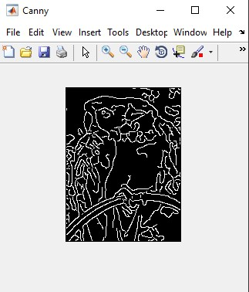

**First derivative with sobel or prewitt is way clearer to recognize with less noise and sharp edges.**

**But second derivative is not very clear and has a lot of noise.**

**And for Canny Algorithm. It has a lot of edges but still can be recognized with sharper edges.**

**So CANNY is someway better.**